**CHAPTER: 5**

**SET UP AND CONNECTIONS**

**ULTRA SONIC ARDUINO UNO:**

GND – GND

echo – 7

trig – 8

Vcc – 5v

**ESP2688 ARDUINO UNO**

1 – 2

2 – GND

3 – 3.3V

7 – 3.3V

8 – 3

**SETUP:**

Attach the ultrasonic sensor to top of the setup facing downward. DC pump to the bottom of the setup and connect a outlet pipe to the pump.

Connect the ESP2688 to the Arduino uno in order to connect to the internet and send the data from this to server.

Place the whole setup on the road sides where water logging.

There is no need for a external server because whole application runs on API calls on developer.here.com and thingspeak.com

The setup is arranged as shown in next figure.

**6**

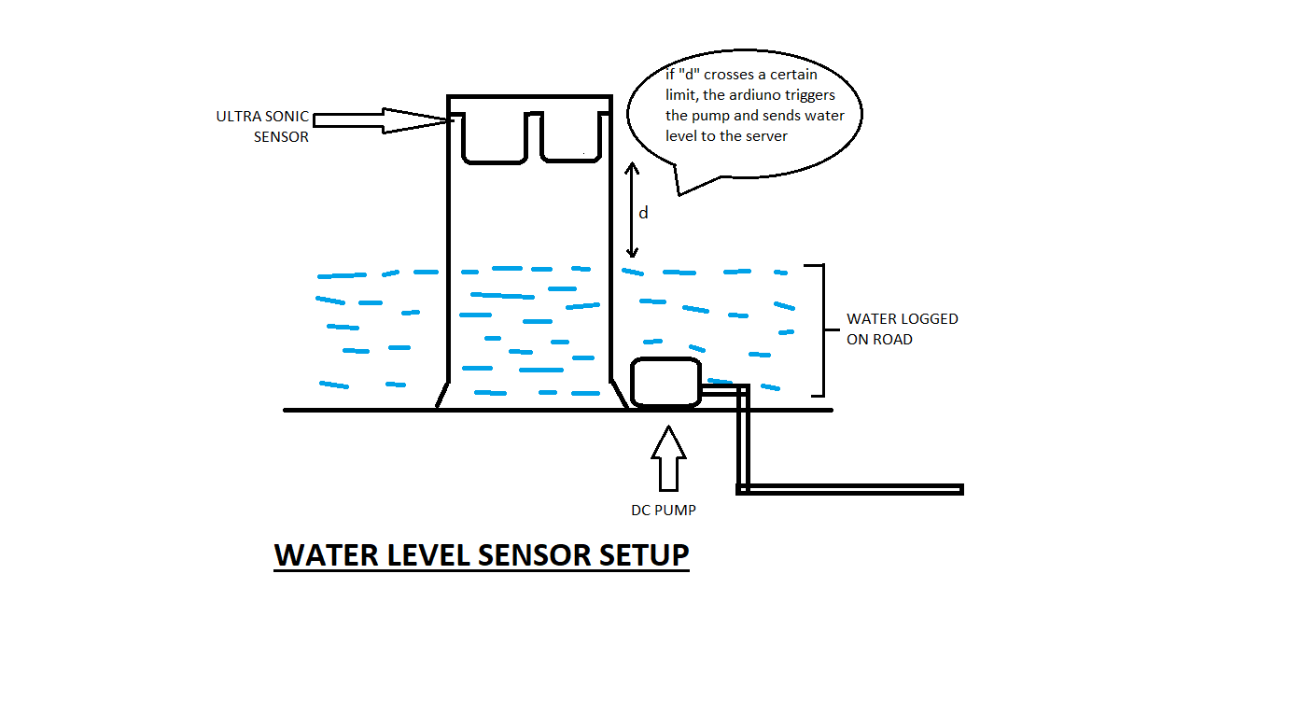

This setup should be made water resistance since this will be set on road sides and it will be under heavy rainfall.

**7**